Kepler’s Laws Lab
This lab has three activities, each exploring one of Kepler’s Laws of Orbital Motion. Note that each activity has Pre-Lab activities and questions to complete before collecting data.

Kepler’s Laws Activity: First Law

Learning Goals
- Explore how the velocity and position of a planet affect the shape of its orbit.
- Describe the characteristics of an ellipse and their relation to planetary orbits.
- Relate geometric concepts with real life trajectories: solar system planets and moons, as well as space missions and other astronomical systems.
- Discover how Kepler’s Laws apply for different bodies in the solar system

Pre-lab Activity
- Draw the first five planetary orbits of the Solar System.

- Suppose you want to send a space mission from Earth’s orbit to Mars. What route do you think it should take? Draw it on your map above.

- What are the possible shapes an orbit could have? Mark which of the following shapes you think could be found in planetary orbits:

Shape | Drawing | Yes/No | Reason (if you have one)
Circle |  | yes | Objects spin around another objects with nothing slowing it down
Triangle |  | no | Nothing to slow objects in space enough to change direction
Square |  | no | Nothing to slow objects in space enough to change direction
Ellipse |  | yes | Objects that enter orbit at an angle will move around a object in non perfect rotation
Rectangle |  | no | Nothing to slow objects in space enough to change direction
Parabola |  | Yes | Its not really a orbit but a object that gets caught in a orbit can be “slingshot” around another celestial object

Open Play
For this activity, we’ll be exploring only the First Law Screen.

Play with the PhET sim for 5 minutes: Kepler’s Laws - First Law. Play with the settings to see what each illustrates. Click on different components of the simulation diagram to see if you can drag them. Describe three main things you have discovered that allow you to change things in the simulation:
- We can adjust the distance of the objects
- We can adjust the velocity
- We can add and remove things like grids, velocities, add other orbits, see speeds, etc..

Collect and Interpret Data

The boundaries of the Solar System:
- Find all of the ways you can change a body’s orbit. Record your observations in the table below

Action | Effect on orbit shape and size | Sketch
Move body closer to the star | The orbit becomes mores ellipse shaped and orbit speeds up
Moved body away from sun | The orbit got larger and slower but remained very circular
Increased velocity as much as I could and moved body closer | Orbit is almost egg shaped and body moves very fast
Moved body far and lowered velocity | The orbit is circular and slow

  - What do all orbits have in common?
They are all rounded orbits

  - What variables affect the orbit’s shape? List all of them
Distance, velocity, gravity, speed, axis, and position

- Describe at least 3 ways to reach edge cases in the simulation (the orbit becomes dashed and a warning message appears on screen). Write the warning message and what you did to reach that orbit.
  - If velocity is too high then we get the message that the object will escape our solar system

  - If we move the body to close than we get the message that the body will collide with the sun

  - If we move the body too far away we also get that it will escape our system

- In each of those situations, how would you get back to a stable orbit?
In every case we have to adjust another variable. If its too close we increase velocity, too far, decrease velocity, and if its moving to fast, we move it closer.

Eccentricity
Check the Eccentricity and Foci checkboxes and create different orbits. You should see the panel below:

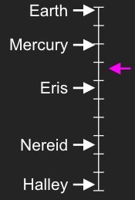
- Changing the orbit, try to get the pink arrow to each object label of the Eccentricity panel (see picture on the left). Describe the process you used to achieve this. I moved the body closer and farther from the sun in order to get the orbits to reach each object

- Describe two ways to create two different orbits with the same eccentricity as Eris.

You can move the body closer to the sun or you can increase the bodies velocity

- Describe in your own words: What is eccentricity?

The difference between two objects in a orbit

- What observations can you make about the Foci related to Eccentricity?

The foci seem to be fixed points that determine the places in which you get the data to calculate the eccentricity

How velocity affects the orbits
Restart the sim. For these challenges, move the velocity arrow only. This can be done by clicking on the arrow and dragging it.
- Discover how to create a circular orbit. Sketch the velocity vector below:
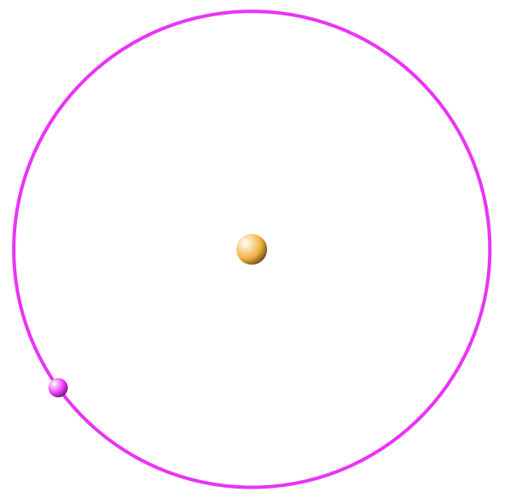

- Create a highly eccentric orbit (eccentricity greater than 0.8) that doesn’t escape or crash into the sun. What characteristics does the velocity have in this scenario?
The velocity is incredibly fast when near the sun but dramatically slows down at greater distance

Mimicking the Solar System
For these challenges you can move the planet and alter its velocity. Check the boxes for: Eccentricity, Foci, Axes, and Semiaxes. The values for the semi-major axis (a), semi-minor axis (b), and the focal distance (c) will be shown below the Eccentricity box at the left.
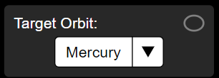

- Use the ‘Target Orbit’ menu to recreate the orbits of the first 5 planets in the solar system and fill the next table with their values

Target Orbit | Semi-major axis, a (AU) | Semi-minor axis, b (AU) | Focal distance, c (AU) | Eccentricity
mercury | 0.40 | 0.39 | 0.08 | 0.20
Venus | 0.70 | 0.70 | 0.01 | 0.00
Earth | 1.00 | 1.00 | 0.02 | 0.02
Mars | 1.50 | 1.49 | 0.14 | 0.09
Jupiter | 5.19 | 5.18 | 0.28 | 0.05

- Use these data which you recorded in the table to draw a more scale realistic orbits of the first five planetary orbits of the Solar System

- Look on the internet for the values of the other planets in the solar system, why do you think they are not represented in the simulation?

The values and orbits are so large and specific that it would be very hard to show on the simulation as well as properly recreate

- Compare your drawing with the one in the pre-lab. Did you learn something new about our solar system? Describe it
I learned just how much bigger Jupiter’s orbit is than Mars

Synthesis of Kepler’s First Law

- Look on the internet or in books for the statement of Kepler’s first Law and write it here:

The orbit of every planet is an ellipse, with the Sun at one of the two foci of that ellipse

  - Based on what you learned from this activity, try to explain this law to an elementary school student using your own words. You can include pictures and screenshots of the simulation!

Orbits are like a oval around the sun we know this by taking the suns location and dividing it by another known location.

Kepler’s Laws Activity: Second Law

Learning Goals
- Explore how the velocity and position of a planet affect the shape of its orbit.
- Visualize what is meant by “swept area of a planet’s orbit” and its relationship with equal time intervals in the context of Kepler’s second Law.
- Describe the behavior of the planet's velocity in different moments of its orbit.

Pre-lab Activity
Look at the following image::
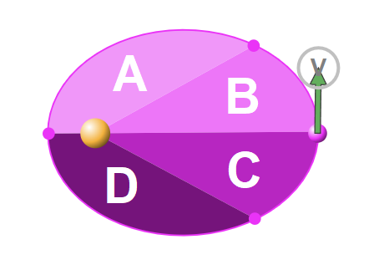

- The picture represents an ellipse whose area has been divided into 4 parts. Which of these parts do you think has the greatest area? Order them from least to greatest area.
C,B,A,D



- This ellipse represents the orbit of the pink planet moving around the yellow sun. In which part of the orbit is the planet going to move faster?
A and D when it is closest to the sun

- Order sections A, B, C and D according to the amount of time it will take the planet to go through them.
From longest to shortest it will be B,C,D,A

- Will there be a difference in the time it takes the planet to go through A+B versus D+C?

Maybe but not that much of a noticeable difference it would also depend on what direction the orbit took clockwise or counterclockwise

Open Play
Allow 5 min to play with the PhET sim. Kepler’s Laws - Second Law. Play with the settings to see what each illustrates. Click on different components of the simulation diagram to see if you can drag them. Describe three main things you have discovered that allow you to change things in the simulation:
- The velocity
- The distance
- The number of period divisions

Collect and Interpret Data

Important Orbital Points

- Activate these checkboxes and play with different orbits. Then, define in your words what are periapsis and apoapsis.

Periapsis is… The closest point in orbit to the sun
Apopasis is… The farthest point in orbit from the sun

- Look in the web for alternate names for these points, and how they are called in other types of orbits:

Type of Orbit | Name for Apoapsis | Name for Periapsis
Orbit around the Sun | aphelion | perihelion
Orbit around the Earth | apogee | perigee
Other interesting orbit?  ______________Mars________ | apoareion | periareion

- How does the velocity change when the planet is on periapsis versus apoapsis? The velocity increases at the apoapsis and decreases at the periapsis

Synthesis of Kepler’s Second Law

Look on the internet or in books for the statement of Kepler’s second Law and write it here: the imaginary line joining a planet and the Sun sweeps out equal areas of space during equal time intervals as the planet orbits

  - Based on what you learned from this activity, try to explain this law to an elementary school student using your own words. You can include pictures and screenshots of the simulation!
In a orbit we split the orbit into equal parts based on where the sun is and our planet is , we can then see where we are closest and farthest. We can also split this orbit into equal sections that would show equal amounts of time.

Kepler’s Laws Activity: Third Law

Learning Goals
- Explore the relationship between the semi-major axis and the period of an orbit, and their corresponding powers described by the Kepler’s Third Law

Pre-lab Activity
[Note: While your textbook uses P to represent the period of an orbit, the simulation uses the variable T instead. Anywhere you see T in the simulation or lab, it is representing the orbital period.]

Distances in the orbit
Unlike the circle, drawing an arbitrary diameter is not enough to measure an ellipse. Instead, we use two important lines called the axes, which are the smallest and biggest possible diameters (minor and major axis respectively).

The most important measurement of an ellipse is certainly the semi-major axis represented with the symbol a, which is the distance measured from the center to the border, along the major axis. The name also indicates that its length is exactly half of the major axis.
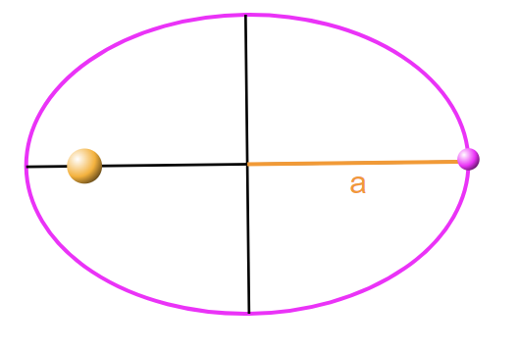
- In the above image, use a ruler to verify that the longest distance from the center is indeed a.

- Think of different shaped orbits. Is the orbital period related to any other property? List the orbital elements you think influence the period.
Yes it is related to the semi major axis and the mass of the body

Open Play
Allow 5 min to play with the PhET sim. Kepler’s Laws - Third Law. Play with the settings to see what each illustrates. Click on different components of the simulation diagram to see if you can drag them. Describe three main things you have discovered that allow you to change things in the simulation:
- Distance
- Velocity
- Star Mass

Collect and Interpret Data

Measuring Periods
Now we will analyze how the Period of a planetary orbit is defined, and different ways to measure it within the simulation.
- Based on the behavior of the Period Tool, how would you define the period of an orbit?
I would describe it as consistent and say that it is the average time it takes for the body to make a full rotation around the sun

- Take multiple period measurements of the same orbit. Does the starting point alter the measurement? Explain No as we still travel the same amount of distance no matter where we start so we will take the same amount of time

- Measure the period of a circular orbit, and compare with the period of more elliptical orbits but with the same semi-major axis:
Type | Period, T (years) | Semi-major axis, a (AU)
Circular | 2.83 | 2.00
Mildly Elliptical | 1.84 | 1.50
Highly Elliptical | 3.39 | 2.26

- What’s your conclusion? Does eccentricity impact the period of an orbit? If so, in what way?
Yes as we orbits we larger and smaller we see that the objects pick up speed when closer to the sun allowing for a faster rebound as It passes by the sun.

- Now let’s make period measurements for different orbits of the solar system. Then, calculate the relation of T/a. For this, remember to use the ‘Target Orbit’ panel to recreate real world orbits:

 | Period, T (years) | Semi-major axis, a (AU) | T/a (AU/years)
Mercury | 0.25 | 0.40 | 0.63
Earth | 1.00 | 1.00 | 1.00
Mars | 1.82 | 1.49 | 1.22

- Do you see any patterns of Period vs Semi-major axis?
  - Does the relation T/a change? How much?
From my observation as we move away from the sun we see the T/a go from being more than T and A on their own to being less

  - For which planets is it bigger?
Mercury

  - Draw the shape of the Graph shown in the simulation:

- Find the combination of exponents for which the relation T/a remains constant for all orbits. Include a screenshot or drawing of the graph, what shape does the graph have now?

Period power: | 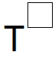 | Graph: 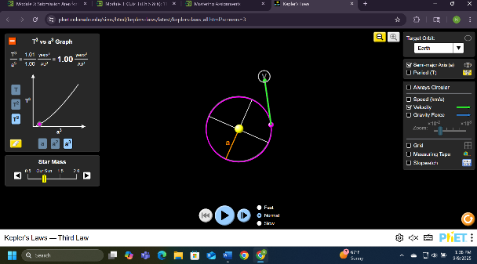
Semi-major axis power: | 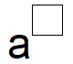

- Find the equation of the curve that you just found.
1/1 =1

- Use the above equation to find out what the semi-major axis of Halley's Comet is, knowing that its period is 76 years. Show your work.

76/1= 76
- Suppose that NASA just discovered an asteroid orbiting the sun with a semi-major axis of 3 AU. Use Kepler’s Third Law to calculate its period in years. Show your work.
Au =3
3^3 = 27
T = sqrt of 27
T = 5.2

Changing Star Mass
- Describe what happens to the relation T/a when the mass of the star changes.

The values shrink and grow depending on if the mass increases or decreases the values act accordingly

- Can you find the new equation for Kepler’s Third Law for a stellar system where the star’s mass is twice as the sun’s?
0.93/1.20 = 0.77

Post-lab Activity
- Look on the internet or in books for the statement of Kepler’s Third Law and write it here:
the square of a planet's orbital period (P²) is directly proportional to the cube of its semi-major axis (a³)

  - Based on what you learned from this activity, try to explain this law to an elementary school student using your own words. You can include pictures and screenshots of the simulation!
If we take the time( years) and multiply it by itself it works with and is a proportion of if we took Au ( distance) and multiplied it by itself 3 times

